Data description(1)
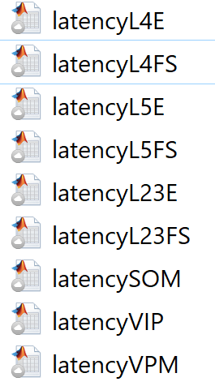
Jianing Yu (jianing.yu@gmail.com)
8/4/2021
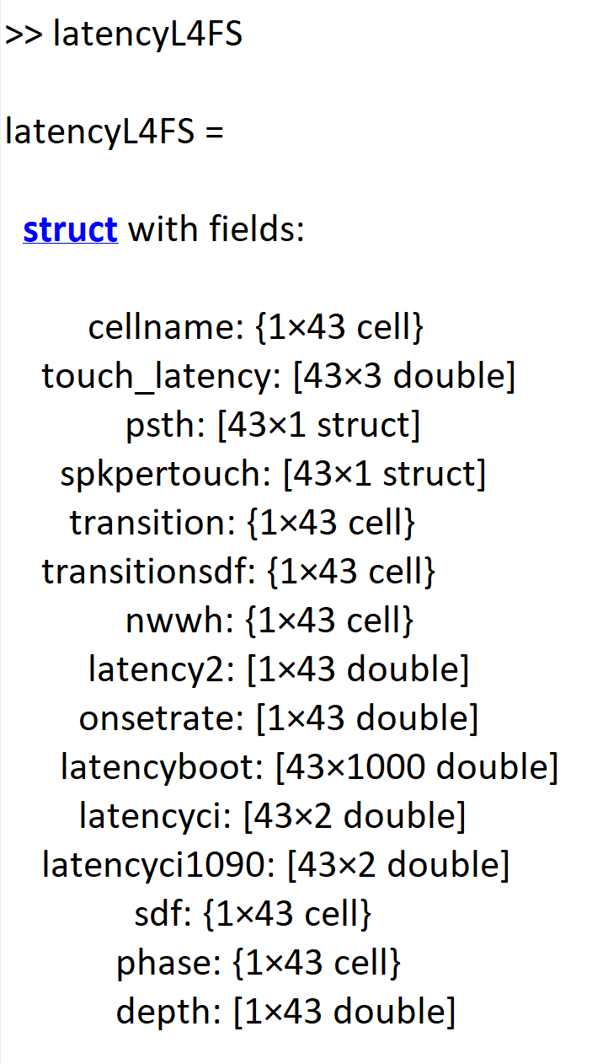

cellname:
This is the name of the cell, e.g., latencyL4FS.cellname{1}
'Exp_2018_09_05_002_0001_0144'

touch_latency
Void. This is the latency of the touch response computed from the rising onset of touch PSTH (onset, peak, max response rate). The original method is prone to error, however. Use latency2 instead (which computes latency based on the time PSTH crosses the half-max).

psth

This is PSTH constructed from touch response. Ret: touch during whisker retraction. Prot: touch during whisker protraction. thist: in seconds.
latencyL4FS.psth(1)
ret: [1×700 double]
thist: [1×700 double]
prot: [1×700 double]
all: [1×700 double]

spkpertouch
This is average spike number evoked from touch (note that ‘nostim =’ is referred to whether there is optogenetic stimulation applied. In other words, nostim is the control, natural conditon)
It is defined as the spk number between 0-50 ms post touch minus a baseline spk number, defined as twice the spke number between 0-25 ms pre touch.
latencyL4FS.spkpertouch(1)
nostim: [3.9713 3.1485 4.6496] mean, 95% confidence interval
nostimspkall: [1001×165 double] spk in(0-50 ms post touch onset) x trials
nostimspkpost_trialbytrial: [1×165 double] # of spikes (0-50 ms post touch) each trial
nostimspkpre: [501×165 double] spk in(-25-0 ms pre touch onset) x trials
nostimraw: 5.5697 average spike num post touch
nostimFF: [2.0784 1.3446 2.8850] Fano factor (variance over mean)

transition
Spike histogram as a function of time (PSTH) around the non-whisking whisking transition (-0.2 to 0.5 sec).

transitionsdf
Same as above computed with spike density function (kernel, 10 ms)
nwwh
Firing rate during whisking or nonwhisking periods.
latency2
latency of touch responses (in sec), computed as the time of half-max.
onsetrate
Spike rate at touch onset (note that touch evoked response hasn’t occurred).
sdf
Touch-evoked response as a function of time, computed with sdf (kernel, 1 ms). ret and prot touches combined.
depth
Depth of cell recorded.

