Raw data description
Jianing Yu (jianing.yu@gmail.com)
9/12/2021

List of cell types and recording methods:

- L4EVm: in vivo whole-cell recording of L4 excitatory cells (P.depth or T.depth tells the recording depth).
- L4ESpikes: cell-attached/juxtacellular recordings of L4 E cells.
- L4FSVm: in vivo whole-cell recording of L4 fast-spiking cells.
- L4FSSpikes: cell-attached/juxtacellular recordings of L4 FS cells.
- L5EVm: in vivo whole-cell recordings of L5/6 E cells.
- L5ESpikes: cell-attached/juxtacellular recordings of L5 E cells.
- L5FSVm: in vivo whole-cell recordings of L5/6 FS cells.
- L5FSSpikes: cell-attached/juxtacellular recordings of L5 FS cells.
- L23ESpikes: cell-attached/juxtacellular recordings of L23 E cells.
- L23FSSpikes: cell-attached/juxtacellular recordings of L23 FS cells.
- SOMVm: in vivo whole-cell recordings of SST cells.
- SOMSpikes: cell-attached/juxtacellular recordings of SST cells.
- VIPSpikes: cell-attached/juxtacellular recordings of VIP cells.

- First, add these folders in Matlab. These are dependent functions.
- These are individual neurons. Each file corresponds to a single cell. Slight difference in their naming convention is due to a switch from ePhus to wavesufer for data acquisition during the project.
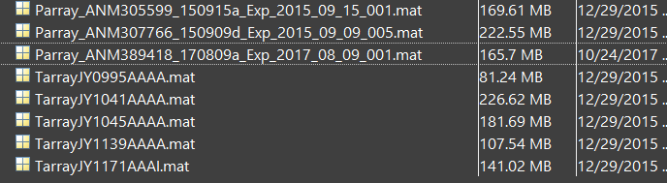

- Load a cell of the old format (Tarray***.mat) and plot a single trial
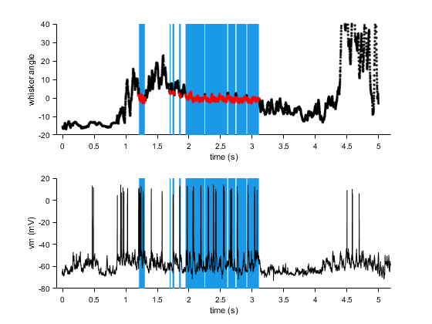

load('TarrayJY0995AAAA.mat');

% This is how you plot whisker angle, touch times, and membrane potential
% of a single trial

itrial = 14;
twhisker = T.trials{itrial}.whiskerTrial.time{1}; % this is the time of each whisker frame, in sec. we captured 5 sec, 1000fps data usually but there were dropping frames sometimes.
% if length(whiskerTrial.time)>1, each cell corresponds to the tracking of a different whisker
whisker_angle = T.trials{itrial}.whiskerTrial.thetaAtBase{1}; % this is the whisker angle
distance_to_pole = T.trials{itrial}.whiskerTrial.distanceToPoleCenter{1}; % this is the distance from pole center to whisker
touch_times = T.contacts{itrial}.contactInds{1}; % this are the index of touch events.

touch_onset = T.contacts{itrial}.segmentInds{1}(:, 1); % onset of touch
touch_offset = T.contacts{itrial}.segmentInds{1}(:, 2); % onset of touch

tvm = T.trials{itrial}.spikesTrial.time - 0.01; % this is to account for a 10 ms latency between ephys and behavior(including whisker acquisition)
vm = T.trials{itrial}.spikesTrial.rawSignal;

% plot this trial

figure;
ha1 = subplot(2, 1, 1)
for i = 1:length(touch_onset)
patch(twhisker([touch_onset(i) touch_offset(i) touch_offset(i) touch_onset(i)]), [-20 -20 40 40], [0.1 0.6 0.9], 'edgecolor', 'none');
end;
hold on
plot(twhisker, whisker_angle, 'k.')
plot(twhisker(touch_times), whisker_angle(touch_times), 'r.');
set(ha1, 'xlim', [-0.1 5.2], 'ylim', [-20 40])
xlabel('time (s)')
ylabel('whisker angle')

ha2 = subplot(2, 1, 2)
for i = 1:length(touch_onset)
patch(twhisker([touch_onset(i) touch_offset(i) touch_offset(i) touch_onset(i)]), [-80 -80 20 20], [0.1 0.6 0.9], 'edgecolor', 'none');
end;
hold on
plot(tvm, vm, 'k')
set(ha2, 'xlim', [-0.1 5.2], 'ylim', [-80 20])
xlabel('time (s)')
ylabel('vm (mV)')

(Note: in a subset of trials, optogenetic stimulation was applied. One can identify these trials by looking at the trial type: T.trials{5}.behavTrial.trialTypeorg. If it includes ‘Stim’, it is a stimulation trial.)

- Load a cell of the old format (Parray***.mat) and plot a single trial

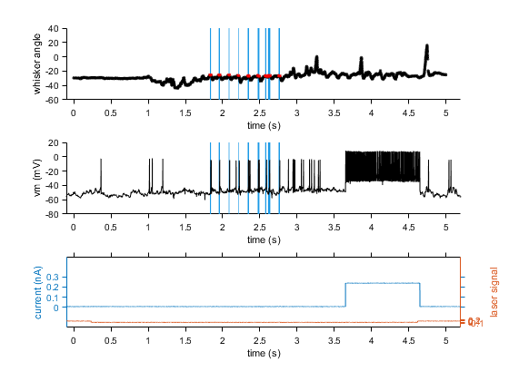
load('Parray_ANM305599_150915a_Exp_2015_09_15_001.mat')

% This is how you plot whisker angle, touch times, and membrane potential
% of a single trial

itrial = 31;
twhisker = P.trials{itrial}.whiskerTrial.time{1}; % this is the time of each whisker frame, in sec. we captured 5 sec, 1000fps data usually but there were dropping frames sometimes.
% if length(whiskerTrial.time)>1, each cell corresponds to the tracking of a different whisker
whisker_angle = P.trials{itrial}.whiskerTrial.thetaAtBase{1}; % this is the whisker angle
distance_to_pole = P.trials{itrial}.whiskerTrial.distanceToPoleCenter{1}; % this is the distance from pole center to whisker
touch_times = P.trials{itrial}.contacts.contactInds{1}; % this are the index of touch events.

touch_onset = P.trials{itrial}.contacts.segmentInds{1}(:, 1); % onset of touch
touch_offset = P.trials{itrial}.contacts.segmentInds{1}(:, 2); % onset of touch

tvm = P.trials{itrial}.ephysTrial.time;
vm = P.trials{itrial}.ephysTrial.rawSignal; % membrane potential
im = P.trials{itrial}.ephysTrial.Iinj; % current injection
opto = P.trials{itrial}.ephysTrial.AOM; % optogenetic stimulation

% plot this trial

figure;
ha1 = subplot(3, 1, 1)
for i = 1:length(touch_onset)
patch(twhisker([touch_onset(i) touch_offset(i) touch_offset(i) touch_onset(i)]), [-60 -60 40 40], [0.1 0.6 0.9], 'edgecolor', 'none');
end;
hold on
plot(twhisker, whisker_angle, 'k.')
plot(twhisker(touch_times), whisker_angle(touch_times), 'r.');
set(ha1, 'xlim', [-0.1 5.2], 'ylim', [-60 40])
xlabel('time (s)')
ylabel('whisker angle')

% plot voltage
ha2 = subplot(3, 1, 2)
for i = 1:length(touch_onset)
patch(twhisker([touch_onset(i) touch_offset(i) touch_offset(i) touch_onset(i)]), [-80 -80 20 20], [0.1 0.6 0.9], 'edgecolor', 'none');
end;
hold on
plot(tvm, vm, 'k')
set(ha2, 'xlim', [-0.1 5.2], 'ylim', [-80 20])
xlabel('time (s)')
ylabel('vm (mV)')

% plot current
ha3 = subplot(3, 1, 3)
hold on
[hAx, hp1, hp2] = plotyy(tvm, im, tvm, opto);
set(hAx(1), 'xlim', [-0.1 5.2], 'ylim', [-0.2 0.5])
set(hAx(2), 'xlim', [-0.1 5.2], 'ylim', [-0.5 6])
xlabel('time (s)')
ylabel(hAx(1), 'current (nA)')
ylabel(hAx(2), 'laser signal')

